CST 352 – Lecture 6 File Systems part 2
Wilsonville, Spring 2022

Example File System UNIX S5FS
Ch 6.1, pag 218

UNIX System 5 File System (S5FS)

To applications, files appear to be a sequence of bytes
Applications don’t need to know…
- About sectors and their addressing scheme
- Record or block size
- How big the file is ahead of time

Files are referenced by name, in a hierarchical path made up of directories

Assumes all sectors are accessible in constant time for simplicity
Doesn’t optimize disk head position, nor attempt to place file sectors to reduce latency
Only attempts to reduce number of disk accesses
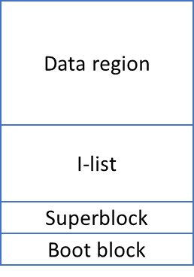

Pg 219 diagram – File System on disk
Boot block code reads OS into memory at boot time
Super block describes layout of file system, heads of free lists
I-List contains inodes (index-nodes) representing directories/files
Data region contains all file data

Directories and files are referenced by “inode”, which is just the index into the I-list
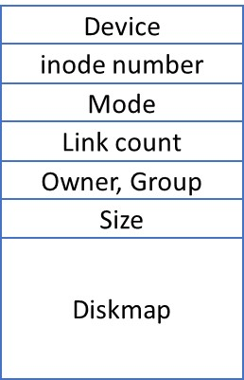

Pg 220 diagram – inode record in I-List
Device refers to which device the file is on
inode number is the index in the I-List
Mode includes read/write/execute permissions
Link count is how many directories include this inode
Owner, Group give access control (security info)
Size is how many bytes are in the file
Diskmap gives references to file’s data sectors
Note: inodes are cached in memory when in use

Pg 220 diagram – Diskmap
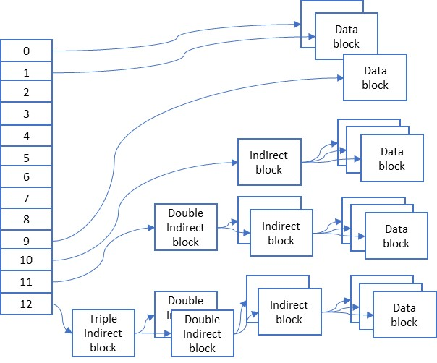

Diskmap must be fixed size, but still list all sectors used for file data
Accomplishes this with a multi-layer data structure:
13 pointers to data blocks (each of 1KB):
0-9 Direct address of 1 data block each (10KB)
10 Addr of “indirect block”, 256 block addrs (256KB)
11 Addr of “double-indirect block”, 256 indirect block addrs (64MB)
12 Addr of “triple-indrect block”, 256 double-indirect block addrs (16GB)

Sequential access to files is efficient:
- Fetch inode from disk and cached in memory when file opened
- Reading the first 10 blocks requires fetch of that block
- Reading the next 256 blocks requires one fetch for indirect block
- etc.

Random access requires more overhead, as entire disk map may need to be read to get the correct block

Sparse files can be efficient as data blocks are allocated only when needed
And various levels of indirect blocks allocated only as needed

Free disk blocks:
Superblock contains address of 100 free blocks
The last free block contains 100 more addresses of free blocks
And so on, until all free blocks are connected this way
When first 100 blocks are used up, just copy linked block of 100 to Superblock

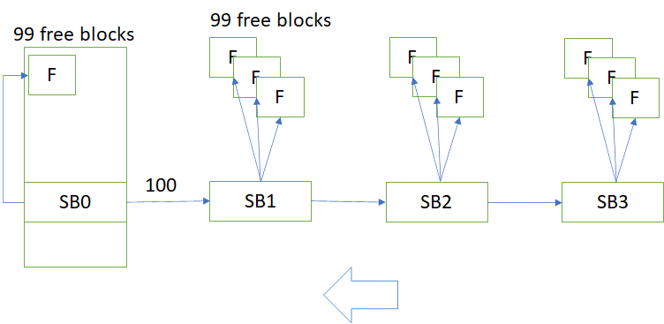

Free inodes:
The I-list contains a fixed number of inodes, each of which is free or allocated
Whenever an inode is allocated or freed, the I-list is updated
Prevents file system structure from being corrupted if the system crashes

Directories are just files (and so inodes)
Data includes “directory entries”, each with a name and inode reference
Finding a directory/file by path…
- Fetch inode for root directory
- Fetch data blocks for directory until next name in path found
- Fetch corresponding inode for directory entry
- Repeat 2-3 until inode found for last name in path

Because directories include name/inode pairs, the same file can be “linked” into multiple directories… this is UNIX soft-linking

Crash Resiliency
Ch 6.2, pg 237

Crashes can cause loss of file data and corruption of entire file system
Some of these issues arise from caching of metadata and file data
Others from physical issues, like bad disk sectors

Requires making sure that the file system is always consistent, even if not complete
Consistency-preserving approach – move from consistent state to consistent state
Transactional approach – only complete operations are preserved, others are rolled back

Transactions follow ACID principle:
Atomic – all or nothing
Consistent – leaves system in a consistent state
Isolated – transactions do not affect each other until committed
Durable – once committed, its persistent

Journaling – steps of transaction written to disk in proper order, once all steps are on the disk, then transaction is “committed” by following the steps. Recovery recognizes if steps have been committed and may roll them back.

Undo Journaling – record current values in journal before updating with new values, so they can be restored during recovery

Redo Journaling – record intended values in journal, so they can be applied during recovery if possible

Undo/Redo journaling used by some file systems, like NTFS (Windows)

Shadow Paging – always write to a new block, then change references to the new block in a single write, leaving the old block in place until the references are confirmed written

See examples of journaled and shadow-paged file systems in sections 6.2.2.2 and 6.2.2.3

Multiple Disks
Ch 6.4, pg 263

Advantages:
- More data storage space available with multiple disks
- Redundancy (disk mirroring or RAID)
- Spread data for parallel read/write to increase performance

Requires virtual file system layer to abstract over disk specifics and join disks together into one file system

Logical Volume Manager (LVM) – abstraction for a “volume” that contains data with one addressing scheme. Maps LVM addresses to disk/address pairs. Allows each disk to have its own addressing scheme.

Striping – Allows parallel access to multiple disks. Block size is a multiple of disk sector size. Each read/write of a block access 1 sector from each disk.
For example: 4 disks → block size = 4 x sector size

RAID – Uses many inexpensive disks of exactly the same characteristsics. Each read/write operation occurs simultaneously over some number of disks. Some disks contain data, some contain error detection / error correction codes. Data and codes are written to multiple disks so everything has some level of redundancy. If a disk goes bad, it’s contents can be recreated from the data on other disks.

https://en.wikipedia.org/wiki/Standard_RAID_levels

Warning: RAID assumes a small number of disks will go bad at one time. Above that threshold and the array is lost. Make sure to replace bad disks immediately! Watch out for disks all with the exact same manufacturer lot number… why?

